**The Document Object**

A Document object represents the HTML document that is displayed in that window. The Document object has various properties that refer to other objects which allow access to and modification of document content.

The way a document content is accessed and modified is called the Document Object Model, or DOM.

The Objects are organized in a hierarchy. This hierarchical structure applies to the organization of objects in a Web document.

* **Window object**: Top of the hierarchy. It is the outmost element of the object hierarchy.
* **Document object**: Each HTML document that gets loaded into a window becomes a document object. The document contains the contents of the page.
* **Form object**: Everything enclosed in the <form>...</form> tags sets the form object.
* **Form control elements**: The form object contains all the elements defined for that object such as text fields, buttons, radio buttons, and checkboxes.

Here is a simple hierarchy of a few important objects:

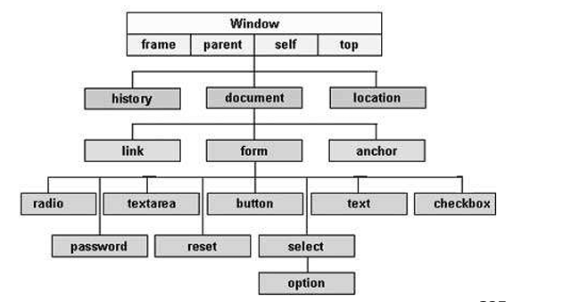

There are several DOMs in existence. The following sections explain each of these DOMs in detail and describe how you can use them to access and modify document content.

* **The Legacy DOM:** This is the model which was introduced in early versions of JavaScript language. It is well supported by all browsers, but allows access only to certain key portions of documents, such as forms, form elements, and images.
* **The W3C DOM:** This document object model allows access and modification of all document content and is standardized by the World Wide Web Consortium (W3C). This model is supported by almost all the modern browsers.
* **The IE4 DOM:** This document object model was introduced in Version 4 of Microsoft's Internet Explorer browser. IE 5 and later versions include support for most basic W3C DOM features.

#### **Key Functions of the Document Object:**

* **document.getElementById(id)**: Returns the element with the specified ID.
* **document.getElementsByClassName(className)**: Returns all elements with a specific class name.
* **document.createElement(tagName)**: Creates a new element in the DOM.
* **document.write(content)**: Writes content directly to the document.

**Form Object**

The Form object represents an HTML form.

For each instance of a <form> tag in an HTML document, a Form object is created.

Form Object Collections

|  |  |
| --- | --- |
| Collection | Description |
| elements[] | Returns an array containing each element in the form |

Form Object Properties

|  |  |
| --- | --- |
| Collection | Description |
| acceptCharset | Sets or returns a list of possible character-sets for the form data |
| action | Sets or returns the action attribute of a form |
| enctype | Sets or returns the MIME type used to encode the content of a form |
| id | Sets or returns the id of a form |
| length | Returns the number of elements in a form |
| method | Sets or returns the HTTP method for sending data to the server |
| name | Sets or returns the name of a form |
| target | Sets or returns where to open the action-URL in a form |

Standard Properties

|  |  |
| --- | --- |
| Property | Description |
| className | Sets or returns the class attribute of an element |
| dir | Sets or returns the direction of text |
| lang | Sets or returns the language code for an element |
| title | Sets or returns an element's advisory title |

Form Object Methods

|  |  |
| --- | --- |
| Method | Description |
| reset() | Resets the values of all elements in a form |
| submit() | Submits a form |